Modify this SOP to be specific to your lab space and any lab-specific procedures that may differ from those listed here.
Standard Operating Procedure
for
Controlled Destruction of Peroxides in Peroxide-Forming Chemicals
Heading/Approval
Building/Room(s) covered by this SOP: | Click here to enter text.
Department: | Click here to enter a date.
Principal Investigator Name:
Principal Investigator Signature/Date: | Click here to enter text.
This SOP was created by: Name/Title/Date/Signature | Click here to enter text.
Section 1 – Process/Protocol
This Standard Operating Procedure (SOP) outlines procedures for the evaluation and controlled destruction of hydroperoxides in organic solvents (only for solutions that do not show visible signs of peroxides and have a peroxide concentration <100 mg/L). This procedure is only to be performed by trained staff and should not be performed alone. Proper PPE and environmental controls are described in later sections but should be implemented before any of the following procedure steps take place.
The procedure can be broken up into 5 discrete steps with critical decision steps taking place in step 1 and step 3:
- Visual Inspection of the container: Personnel must visually inspect the container before moving on to subsequent steps. If any of the following characteristics are observed, a decision to call off the procedure must be made: wispy or needle-like crystals forming in the container (image below), clear separation of liquid layers in the bottle, cloudiness in the liquid, crystals of any size or shape near the cap of the bottle, or any indication of peroxide formation with <10% of the liquid remaining in the bottle. For dark containers, use a flashlight to view within the container. If the peroxide-forming chemical is in a completely opaque container, expert judgment must be made based on the age and condition of the container. If any of these conditions are present, leave the container in place and do not handle it any further. Block off access to the container and call EHS (360-650-3064). Assuming that none of the above conditions are present, you may then proceed to step 2.
- Slowly and with extreme caution, remove the cap from the container. This is often the most hazardous step in this SOP as some peroxides are shock/friction sensitive.
- Test the peroxide concentration using a commercial test strip following all manufacturer directions.
  - If the solution is <10 mg/L, destruction of peroxides is not necessary.
  - If the solution is ≥10 mg/L but <100 mg/L, you may move on to step 4.
  - If the solution is ≥100 mg/L, lightly place cap back on the container but do not screw closed. Block off access to the container and call EHS (360-650-3064).
- This SOP addresses destruction through ferrous sulfate or ferrous ammonium sulfate. These methods are suitable for most diacyl peroxides except those that have low solubility in water.
Removal of peroxides with ferrous sulfate:
  - A solution of 6 g of FeSO4 · 7H2O, 0.6 mL of concentrated sulfuric acid, and 11 mL of water is slowly added and stirred with 1 L of water-insoluble solvent until the solvent no longer gives a positive test for peroxides. Usually only a few minutes are required.
Removal of peroxides with ferrous ammonium sulfate:
  - The peroxide forming chemical is first diluted by 30-50% using 70% ethanol.
  - 2 tablespoons of (NH₄)₂Fe(SO₄)₂ · 6H₂O is dissolved into 500mL water.
  - Ferrous solution is slowly added to peroxide forming chemical and is thoroughly mixed.
BOTH of the procedures above generate heat and must be carried out slowly. If solvent begins to boil, close the fume hood sash and allow to cool before adding additional ferrous sulfate solution.
- Retest the solution using a commercial test strip following all manufacturer directions.
- When peroxide concentration is brought below 10 mg/L, stabilize the container with butylated hydroxytoluene (BHT) to prevent additional peroxide formation. Write the final peroxide concentration, date tested, and what inhibitor was added. Add a hazardous waste label listing all chemical components and place in its respective waste location.
NOTE: Any deviation from this SOP requires approval from Principal Investigator.

Section 2 – Chemicals and Hazards
Peroxide forming chemicals have a variety of hazards associated with them. Most are flammable and at least moderately toxic. Some may be very toxic. Some may be carcinogens or teratogens. When peroxides are formed, the peroxides are strong oxidizers and may be explosive in certain circumstances.
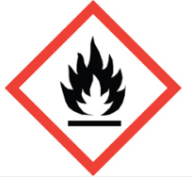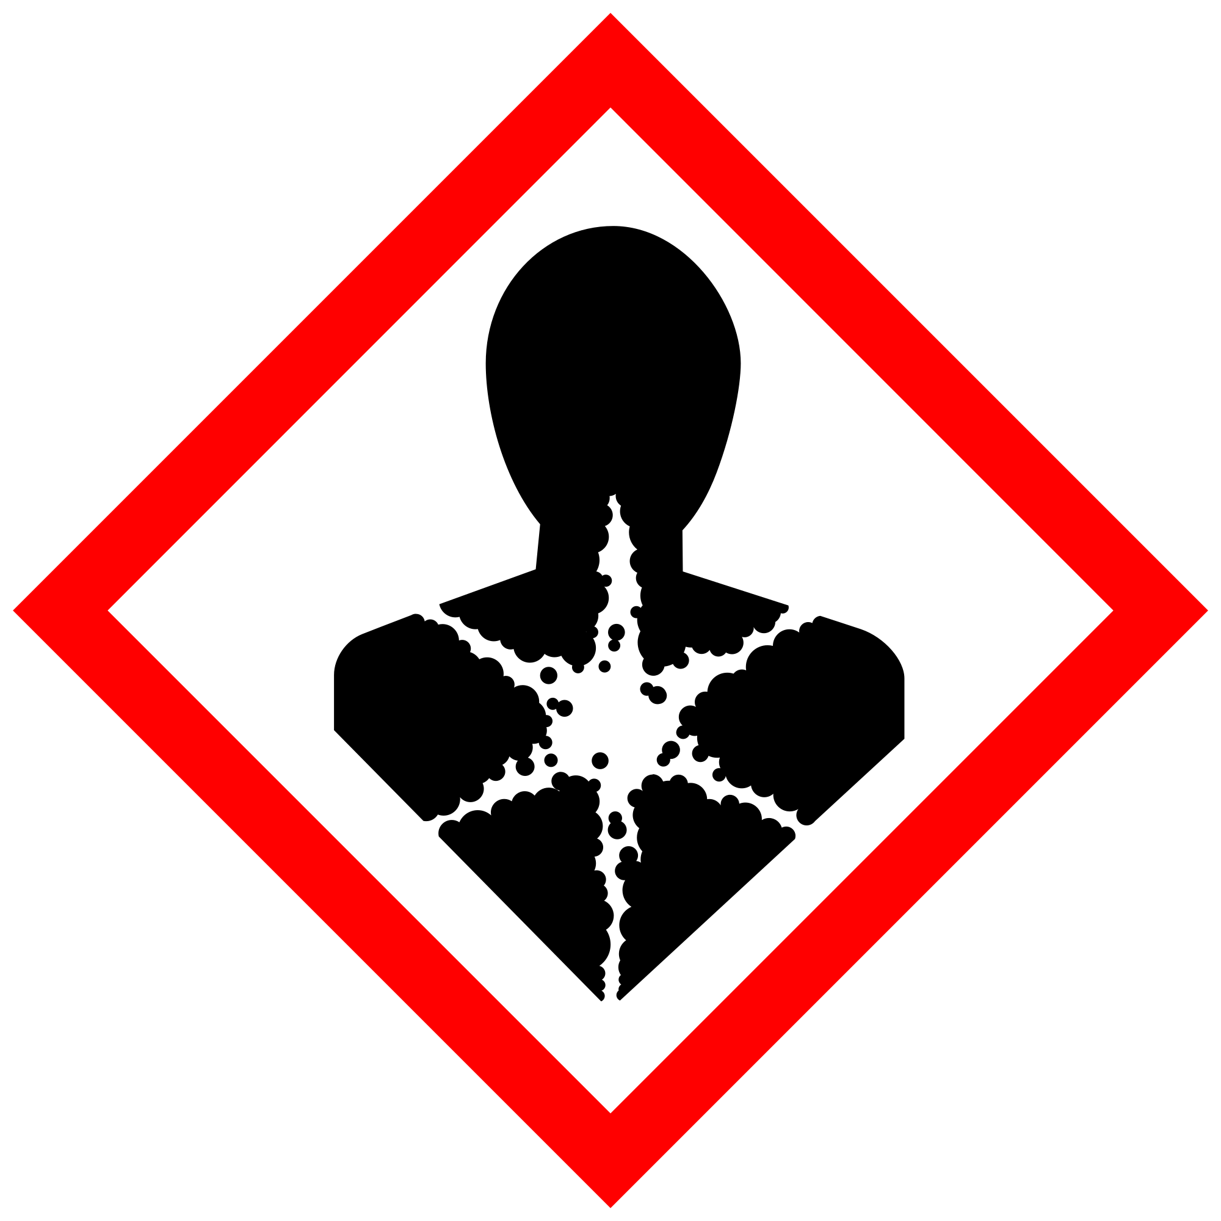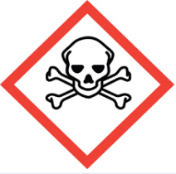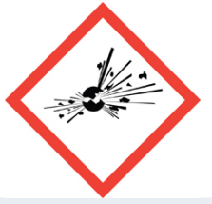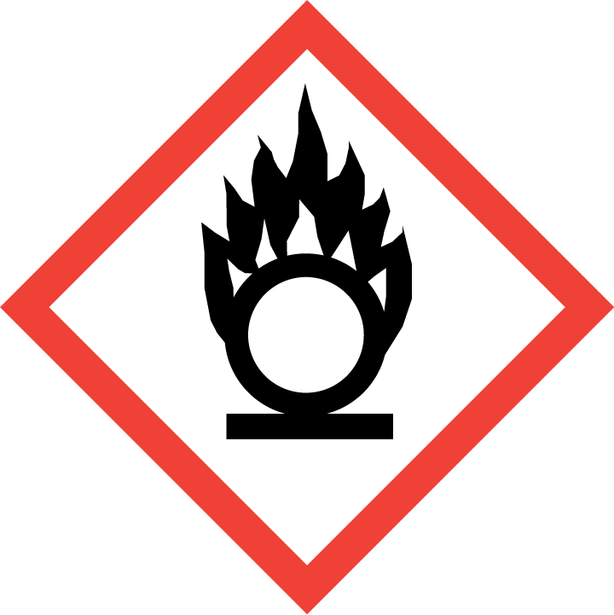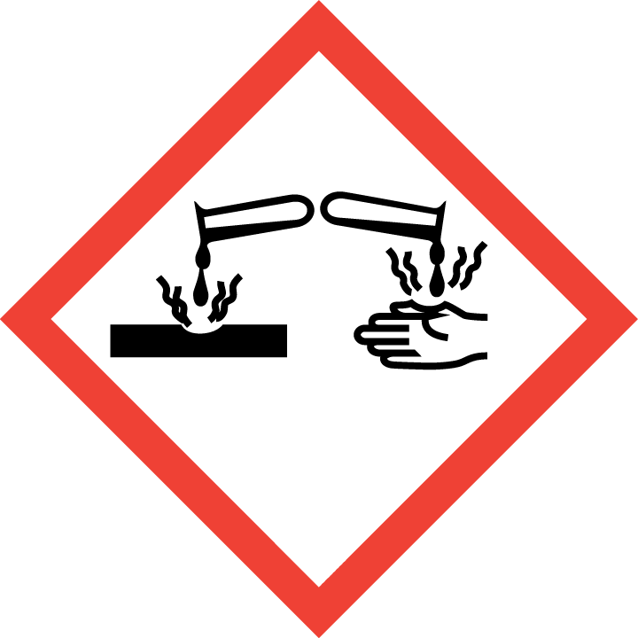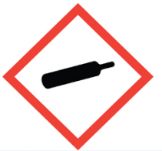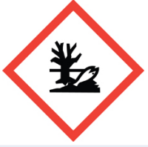

Section 3 – Environmental/Ventilation Controls
Peroxide destruction will always be carried out in secondary containment in an uncluttered fume hood. Ensure that there are not other hazardous materials in the vicinity that may make the situation worse should an emergency occur.
Section 4 –Personal Protective Equipment (PPE)
General Hygiene Measures:
Avoid contact with skin, eyes, and clothing. Wash hands after removing PPE before breaks and immediately after handling the chemical. If chemicals that are being combined come into contact with any PPE, the PPE shall be immediately removed and discarded properly. Any potentially exposed body parts should be washed immediately.
PPE:
Skin and Body Protection. Personnel must wear full-length pants, or equivalent, and close-toed shoes. The area of skin between the shoe and ankle must not be exposed. A standard knee-length lab coat must be worn over the personal clothing.
Hand Protection. Hand protection is required for the activities described in this SOP. It is recommended that 11-15mil re-usable nitrile gloves be worn for this procedure.
Gloves must be inspected prior to use, including a check for pinholes.
Use proper glove removal technique (without touching glove's outer surface) to avoid skin contact with this product. Dispose of contaminated gloves after use in accordance with applicable laws and good laboratory practices. Wash and dry hands immediately after glove removal.
Eye Protection. Eye protection is required for the activities described in this SOP. Chemical splash goggles are required.
Respiratory Protection. Respiratory protection is not required for the activities described in this SOP.

Section 5 – Special Handling and Storage Requirements
- This work will ideally be performed with a co-worker to assist in the event of an emergency.
- Peroxide destruction procedures should be carried out slowly!
- Peroxide destruction will always be done in the fume hood inside of secondary containment.
- Clean the fume hood upon completion of tasks with 70% ethanol or a soap and water solution.
- Clean all contaminated surfaces with 70% ethanol or a soap and water solution and dry.
- When work is completed, remove gloves and wash hands with soap and water.

Section 6 – Spill and Accident Procedures
Only clean spills if safe to do so and you have been trained in proper spill response. Because this SOP covers a wide variety of chemicals, groups need to develop response procedures specific to the chemicals being handled. Spills outside of the fume hood warrant special consideration as depending on the chemical, respiratory protection may be required to safely address the spill.
Chemical spills must be cleaned up as soon as possible by properly protected and trained personnel. All other persons should leave the area. Spill response procedures must be developed based on the chemical and potential spill or release conditions. Clean up spills using contents of the laboratory spill kit: Universal Spill kit. Do not attempt to clean up any spill if not trained or comfortable. Evacuate the area and call EHS at 360.650.3064 during business hours (8am-5pm) or emergency services at 360.650.3911 or 911 outside of business hours. If the spill is out of control, call 360.650.3911 or 911. If a person is injured, exposed or suspected of being exposed, call 360.650.3911 or 911. *Follow EXPOSURE PROCEDURES (below).
Spill area must be cleaned up in the following manner: Absorb spilled material using the universal spill kit. Peroxides may still need to be destroyed on the spill cleanup material depending on the peroxide concentration.
Spill cleanup material should be treated and tested for residual peroxides. When peroxides can no longer be detected, all material should be placed in a sealed bag and disposed of as hazardous chemical waste.
Any spill incident requires the involved person or supervisor to complete and submit an Incident Report within 24 hours of the incident to EHS. For any incidents that resulted in hospitalization or death, EHS must be contacted as soon as possible at 360.650.3064 (8am-5pm) or 360.650.3555 outside of business hours.
Exposures: Because this SOP covers a wide variety of chemicals, groups need to develop response procedures specific to the chemicals being handled. If a person is injured, exposed, or suspected of being exposed to peroxide forming chemicals, refer to the SDS of the particular chemical. In general:
Perform First Aid Immediately
- For inhalation exposure: move out of contaminated area; get medical help
- For skin exposure: use the nearest safety shower for 15 minutes; stay under the shower and remove clothing; use a clean lab coat or spare clothing for cover‐up.
- For eye exposure: use the eye wash for 15 minutes while holding eyelids open.
Get Help
- Call 360.650.3911 or 911 or go to nearest Emergency Department (ED); provide details of exposure:
o Agent
o Dose
o Route of exposure
o Time since exposure
- Bring to the ED the SDS and this SOP
- Notify your supervisor as soon as possible for assistance
- Secure area before leaving; lock doors and indicate spill if needed
Report Incident to Environmental Health and Safety
Any exposure incident requires the involved person or supervisor to complete and submit an Incident Report within 24 hours of the incident to EHS. For any incidents that resulted in hospitalization or death, EHS must be contacted as soon as possible at 360.650.3064 (8am-5pm) or 360.650.3555 outside of business hours.

Section 9 – Approvals required
All staff performing peroxide destruction must be trained on this SOP prior to starting work. All training must be documented and maintained by the PI or their designee.
- Respirator Medical Clearance is required prior to carrying out this SOP.

Section 10 – Documentation of Training (signature of all users is required)
- Prior to using substances included in this SOP, laboratory personnel must be trained on the hazards described in this SOP, how to protect themselves from the hazards, and emergency procedures.
- Ready access to this SOP and to a Safety Data Sheet for each hazardous material described in the SOP must be made available in the lab space(s) where these substances are used.
- The Principal Investigator (PI), or Responsible Party, if the activity does not involve a PI, must ensure that their laboratory personnel have attended appropriate laboratory safety training (and refresher training where applicable).
- Training must be repeated following any revision to the content of this SOP. Training must be documented. This training sheet is provided as one option; other forms of training documentation (including electronic) are acceptable but records must be accessible and immediately available upon request.
I have read and understand the content of this SOP:
Name | Signature | Date
Click here to enter text. |  | Click here to enter a date.
Click here to enter text. |  | Click here to enter a date.
Click here to enter text. |  | Click here to enter a date.
Click here to enter text. |  | Click here to enter a date.
Click here to enter text. |  | Click here to enter a date.
Click here to enter text. |  | Click here to enter a date.
Click here to enter text. |  | Click here to enter a date.
Click here to enter text. |  | Click here to enter a date.
Click here to enter text. |  | Click here to enter a date.
Click here to enter text. |  | Click here to enter a date.
Click here to enter text. |  | Click here to enter a date.
Click here to enter text. |  | Click here to enter a date.
Click here to enter text. |  | Click here to enter a date.
Click here to enter text. |  | Click here to enter a date.
Click here to enter text. |  | Click here to enter a date.
Click here to enter text. |  | Click here to enter a date.
Click here to enter text. |  | Click here to enter a date.
Click here to enter text. |  | Click here to enter a date.

