Western Washington University Biomedical Waste Treatment Plan (revised 2021)

- Scope
  - This Plan is provided to fulfil the permit requirements of Whatcom County Public Health Code Chapter 24.06 Solid Waste Rules and Regulations – Standards and Permits. Western Washington University (WWU) generates and treats biomedical waste as defined by Sections 24.06.030 and 24.06.040.

- WWU Biomedical Waste Summary
  - WWU is not a commercial biomedical waste treatment facility and does not accept or receive biomedical waste from any non-WWU associated generators. Biomedical waste treated on-site is generated by two main WWU groups; Research/Laboratory Departments and the Student Health Clinic.

  - Research/Laboratory Waste
    - This waste is generated by WWU research or student teaching laboratories and activities. Wastes are primarily CDC biohazard level I and II wastes (BSL-1 and BSL-2). WWU activities do not generate biohazard level III (BSL-3) wastes. Wastes generated include:
      - Cultures and Stocks
      - Human blood and blood products
      - Sharps Waste
      - Disposable items contaminated by the above
    - The wastes described above are rendered inactive by steam sterilization in validated autoclaves to ensure a 6 log reduction of any potentially contaminated materials. The sterilization process details are provided below in Sections 3. Research/Laboratory Waste Treatment Process and 4. Sterilization Equipment.
    - Any untreated wastes are collected within WWU buildings and only transported within the WWU campus as provided on the facility site plan included below. No untreated waste is transported on public, city, county, or state roads by WWU.
    - In 2017 the total amount of solid waste treated and sent to landfill logged at 2,200 pounds. The average total weight of solid waste processed by research/laboratory departments for the previous three years was logged as: 2,276 pounds per year.

  - Student Health Services Waste
    - This waste is generated by the activities provided by the Student Health Center’s medical practice. Wastes generated include:
      - Disposable items contaminated by human blood and blood products
      - Sharps waste
    - Both sharps and non-sharps wastes are collected in appropriate biohazard containers or puncture resistant sharps containers and picked up by the vendor Stericycle for transport to their treatment facility in Woodinville, WA for final disposition.
    - Vendor Information:
Stericycle Corporate Headquarters
28161 N. Keith Drive
Lake Forest, IL 60045

- Research/Laboratory Waste Treatment Process
  - Solid non-sharp waste
    - Biohazard waste is segregated from other waste and collected at the point of origin in biohazard specific containers lined with an autoclave bag. Outer collection containers and autoclave bags are labeled with the universal biohazard symbol.
    - When bags are ¾ full, bag ends are rolled over, taped shut, and labeled with point of origin’s identification information. Bags are transferred in secondary containers to the Biology Building 4th Floor Autoclave Room.
    - Only trained staff process the bagged waste and run the autoclave.
    - Staff wear lab coat, gloves, and face protection as needed when handling untreated wastes.
    - Records for each load of sterilized waste are kept in an autoclave specific log book. Pre-sterilization weight, load size, type, and sterilization parameters are recorded before sterilization begins.
    - All waste is autoclaved for a minimum of 60 minutes at 121 degrees Celsius and 16 psi using steam sterilization.
    - When the sterilization cycle is complete users verify that temperature and pressure were at or exceeded 121 C and 16 psi for at least 60 minutes and record pass/fail in the log book.
    - Treated red bags are then placed into black garbage bags.
    - Black-bagged treated waste is then transferred to the ground level and placed in building dumpster for disposal.
    - Chemical disinfection is utilized if spills or leaks occur within the facility.

  - Sharps waste
    - Differentiating Biohazardous Sharps and Non-Biohazardous Sharps:
      - Biohazardous sharps waste generated in biomedical settings and biological labs includes “all hypodermic needles, syringes with needles attached, IV tubing with needles attached, scalpel blades, and lancets that have been removed from the original sterile package.” (RCW 70A.228.010) Additionally, the following are defined as biohazardous sharps waste if they are contaminated with biological hazards, including recombinant and synthetic DNA or RNA: broken glass, razor blades, glass slides, cover slips, and fragile glass items (ampoules, Pasteur pipettes).
      - Non-biohazardous sharps waste are those generated in non-biological lab spaces and have never come in contact with biological materials.
    - Biohazardous sharps waste must collected on site in puncture resistant sharps containers, labeled with the universal biohazard symbol. Sharps containers must not be filled more than two-thirds full. When two-thirds full, the lid must be closed and autoclave indicating tape placed over the lid and sides, taking care not to cover the vent holes. The PI’s name and room number should be clearly marked on the container. The sharps waste generator is responsible for ensuring proper sterilization with a registered autoclave (see Section 4). All closed and sterilized sharps containers are then collected by WWU EHS for final disposition.
    - Non-biohazardous sharps waste must be collected on site in puncture resistant sharps containers, with the universal biohazard symbol defaced or in containers without a biohazard symbol. Sharps containers must not be filled more than two-thirds full. When two-thirds full, the lid must be closed. The PI’s name and room number should be clearly marked on the container. All closed sharps containers are then collected by WWU EHS for final disposition. If any biohazardous sharps enter a non-biohazardous sharps container, a biohazard symbol must be affixed and the entire container must be handled as described in 3.2.2.
    - The vendor collects containers every 24 weeks for transport to their treatment facility in Kent WA. Sharps Collection Vendor Info:
WM Healthcare Solutions Inc.
1001 Fannin St Ste 4000
Houston, TX 77002

- Sterilization Equipment: Operations, Maintenance Procedures, Equipment calibration processes
  - Two Steam Sterilizing Autoclaves AMSCO brand Eagle 3000 Series Small Sterilizers located in BI 448 are used to process and inactivate all research/laboratory waste prior to disposal into university dumpsters.
    - Main Autoclave: SN 012609308
    - Back-up Autoclave: SN 0117694-05
    - Unit manufacture information is included in Appendix 1.
    - Maintenance and calibration is performed by the vendor STERIS.
    - Autoclaves are on a quarterly preventative maintenance schedule.
    - Unit probes for temperature and pressure are calibrated annually.
    - Units are inspected every two years by a qualified state inspector.
    - Vendor Information:
STERIS Corporation
5960 Heisley Road Mentor
OH 44060-1834

  - Autoclave Monitoring Procedures to ensure sterilization
  - CDC recommends using biological indicators or spore tests to monitor sterilization. WWU uses Geobacillus stearothermophilus indicators to test the efficacy of treatment procedures. Geobacillus stearothermophilus is a thermophilic organism with an optimum growth temperature range of 55°C – 60°C. To comply with ISO 11138-3, steam D121-values for a standard BI must be ≥ 1.5 minutes and a Z-value ≥ 6°C determined from three temperatures ranging from 110°C – 130°C (Six log reduction). Z-value is a term used in microbial thermal death time calculations. It is the number of degrees the temperature has to be increased to achieve a tenfold (i.e. 1 log₁₀) reduction in the D-value. D-value refers to decimal reduction time (or decimal reduction dose) and is the time (or dose) required at a given condition (e.g. temperature), or set of conditions, to kill 90% (or 1 log) of the exposed microorganisms.
  - Monthly the autoclave sterilization cycles of 121 C and 16 psi for 60 minutes are tested using a Geobacillus stearothermophilus biological indicator to ensure a six log reduction is occurring. A Madge Tech probe is used to monitor the temperature and pressure cycling during the run to validate sterilization parameters.
  - If sterilization does not meet the requirements of the monthly test or if the autoclave is not working properly staff discontinue use, post a sign alerting others to discontinue use, and notify lab manager so that the vendor can be brought in for repairs.
  - Any untreated waste is held in the waste room in secondary containment until it can be sterilized and processed for disposal.

- Facility site plan
  - WWU Campus Map
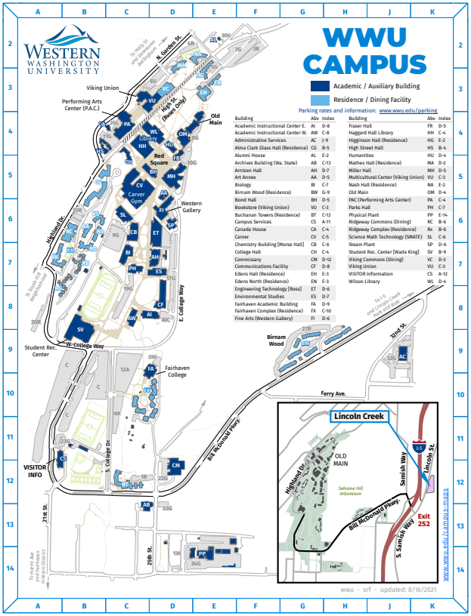

  - Biology Building 4th Floorplan
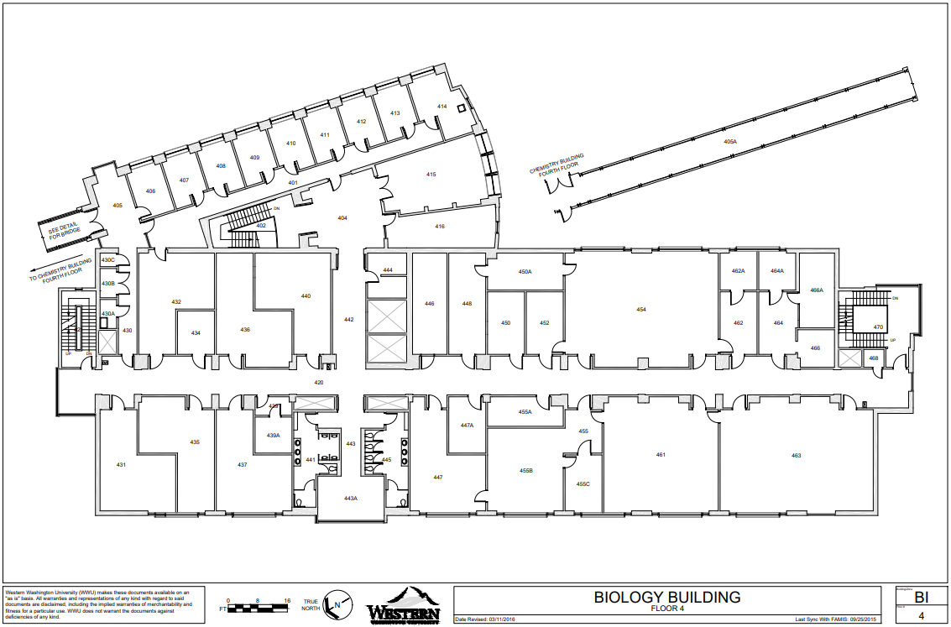
- Vector control procedures
  - Pest control is managed by Western Washington Universities Facilities Management, Grounds Shop.
  - Regular building inspections are scheduled monthly to identify any pest presence or conditions conducive to infestation. Preventative maintenance inspections include mechanical and utility spaces.
  - Rodent bait stations are located near the loading dock entrance to the Biology Building. Bait stations are on a monthly inspection schedule.
  - Building occupants are trained to report any pest sightings immediately to Facilities Management.
  - To date no pest issues have been reported in the Biology Building.

- Training
  - Any operator autoclaving and disposing of biohazardous waste are trained in proper sterilization and disposal procedures. All staff are provided with the following safety training:
    - WWU general safety requirements
    - Biology department specific safety requirements (includes Hazard ID, PPE use, local safety controls, and accident/ incident procedures
    - Autoclave use and waste sterilization training

- Employee Health and Safety / Medical monitoring
  - Periodic waste profile evaluations are performed to determine the risks of exposure to infectious materials for waste handlers and the need for medical monitoring and vaccination. At the time of this submittal medical monitoring and TB testing are not warranted based on the types of waste that are currently processed at WWU.

  - University Policy states that the Hepatitis B (HBV) vaccination is offered to all employees who may be occupationally exposed to blood. Vaccinations are given at no cost, at a reasonable time and place, and performed by or under the supervision of a licensed physician or other licensed health care professional. Exceptions are if the employee has had a previous HBV vaccination or if antibody testing indicates that the employee is immune. The employee may initially decline the vaccination and accept it at a later time. If booster dose(s) are recommended in the future, they are provided according to standard medical practices.

  - HBV antibody testing is available to an employee who desires such testing prior to deciding whether or not to receive HBV vaccination. If the employee is immune to HBV because of an adequate antibody titer (concentration in the blood), then the University is not required to offer vaccine.

- Emergency procedures
  - Any spills are immediately isolated and treated with an EPA-registered tuberculocidal agent, a registered germicide on the EPA Lists D and E (i.e. a freshly diluted sodium hypochlorite solution)
    - Spill Procedure for untreated biological waste:
      - Isolate the spill. Cover with paper towel or other absorbent materials.
      - Saturate the spill and absorbent materials with 10% sodium hypochlorite solution.
      - Let stand for 20 minutes.
      - Collect all absorbents and dispose in the trash.
      - Wipe the affected area again with a clean cloth and 10% sodium hypochlorite solution.
    - Employee Decontamination Procedure: Should an employee be contaminated with untreated biological waste.
      - Remove the laboratory coat and any contaminated clothing is immediately.
      - Place removed and put in an autoclave bag sterilization.
      - Contaminated persons should enter the safety shower and use soap and water to remove any potential contamination.
      - Collected shower water is treated with 10% sodium hypochlorite for 20 minutes to inactive any potential contaminates prior to disposal

- Recordkeeping
  - The current copy of this plan is kept on file at the WWU EHS office.
  - Waste log sheets are kept onsite at Biology Building. Annual completed logs are submitted to the WWU EHS office.
  - All waste logs, treatment records, equipment testing/ calibration, efficacy of treatment, testing and infectious waste management correspondence are maintained on site for 3 years.

- Document Attributes
Title | Western Washington University Biomedical Waste Plan
Author | Christine Tafoya, Safety Officer, SM (NRCM), CBSP | Date of Origin | 09-20-2017
Reviewed/  Revised by | Sue Sullivan, Director  Grant Whitman, Safety Officer | Dates Reviewed/  Revised | 9-20-2017  01-08-2018  09-28-2021
Copyright | © Western Washington University, 2021 | Last Modified | 09-28-2021
Approved | Signature on File  Director, Environmental Health and Safety. Western Washington University.

