This is an SOP template and is not complete until:
1) all RED TEXT has been edited to reflect chemical/lab-specific information, including relevant procedure information, or deleted if inapplicable, and 2) SOP has been signed and dated by the PI and relevant lab personnel. Use Safety Data Sheets (SDSs) as a resource for chemical-specific information.
Standard Operating Procedure
for
Chemical(s)/Process(es) REQUIRED - List chemical(s)/processes and CAS numbers here
Heading/Approval
Building/Room(s) covered by this SOP: | Click here to enter text.
Department: | Click here to enter text.
Principal Investigator Name: | Click here to enter text.
Principal Investigator Signature/Date: | Click here to enter text.
This SOP was created by (if not PI): Name/Title/Date/Signature/Date | Click here to enter text.
Section 1 – Process/Protocol
Provide an overview of the procedure. Insert or attach laboratory-specific procedures, hazardous chemical(s), or hazard class. You may also include any relevant supporting resources such as journal citations, etc. that are applicable.
NOTE: Any deviation from this SOP requires approval from Principal Investigator.

Section 2 – Chemicals and Hazards
Obtain this information from SDS. Include regulatory information if chemical is a particularly hazardous substance.
Identify the stock chemicals, intermediates, final compounds and wastes involved, and such factors as use of catalysts or inert compounds.
Describe hazards associated with this/these chemicals, including but not limited to:
- routes of exposure
- how exposure might occur
- target organs
- signs and symptoms of exposure
- expected by-product(s) if this SOP covers a laboratory process
Use GHS Pictograms as appropriate, refer to SDS(s):
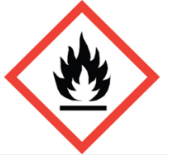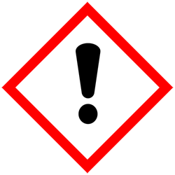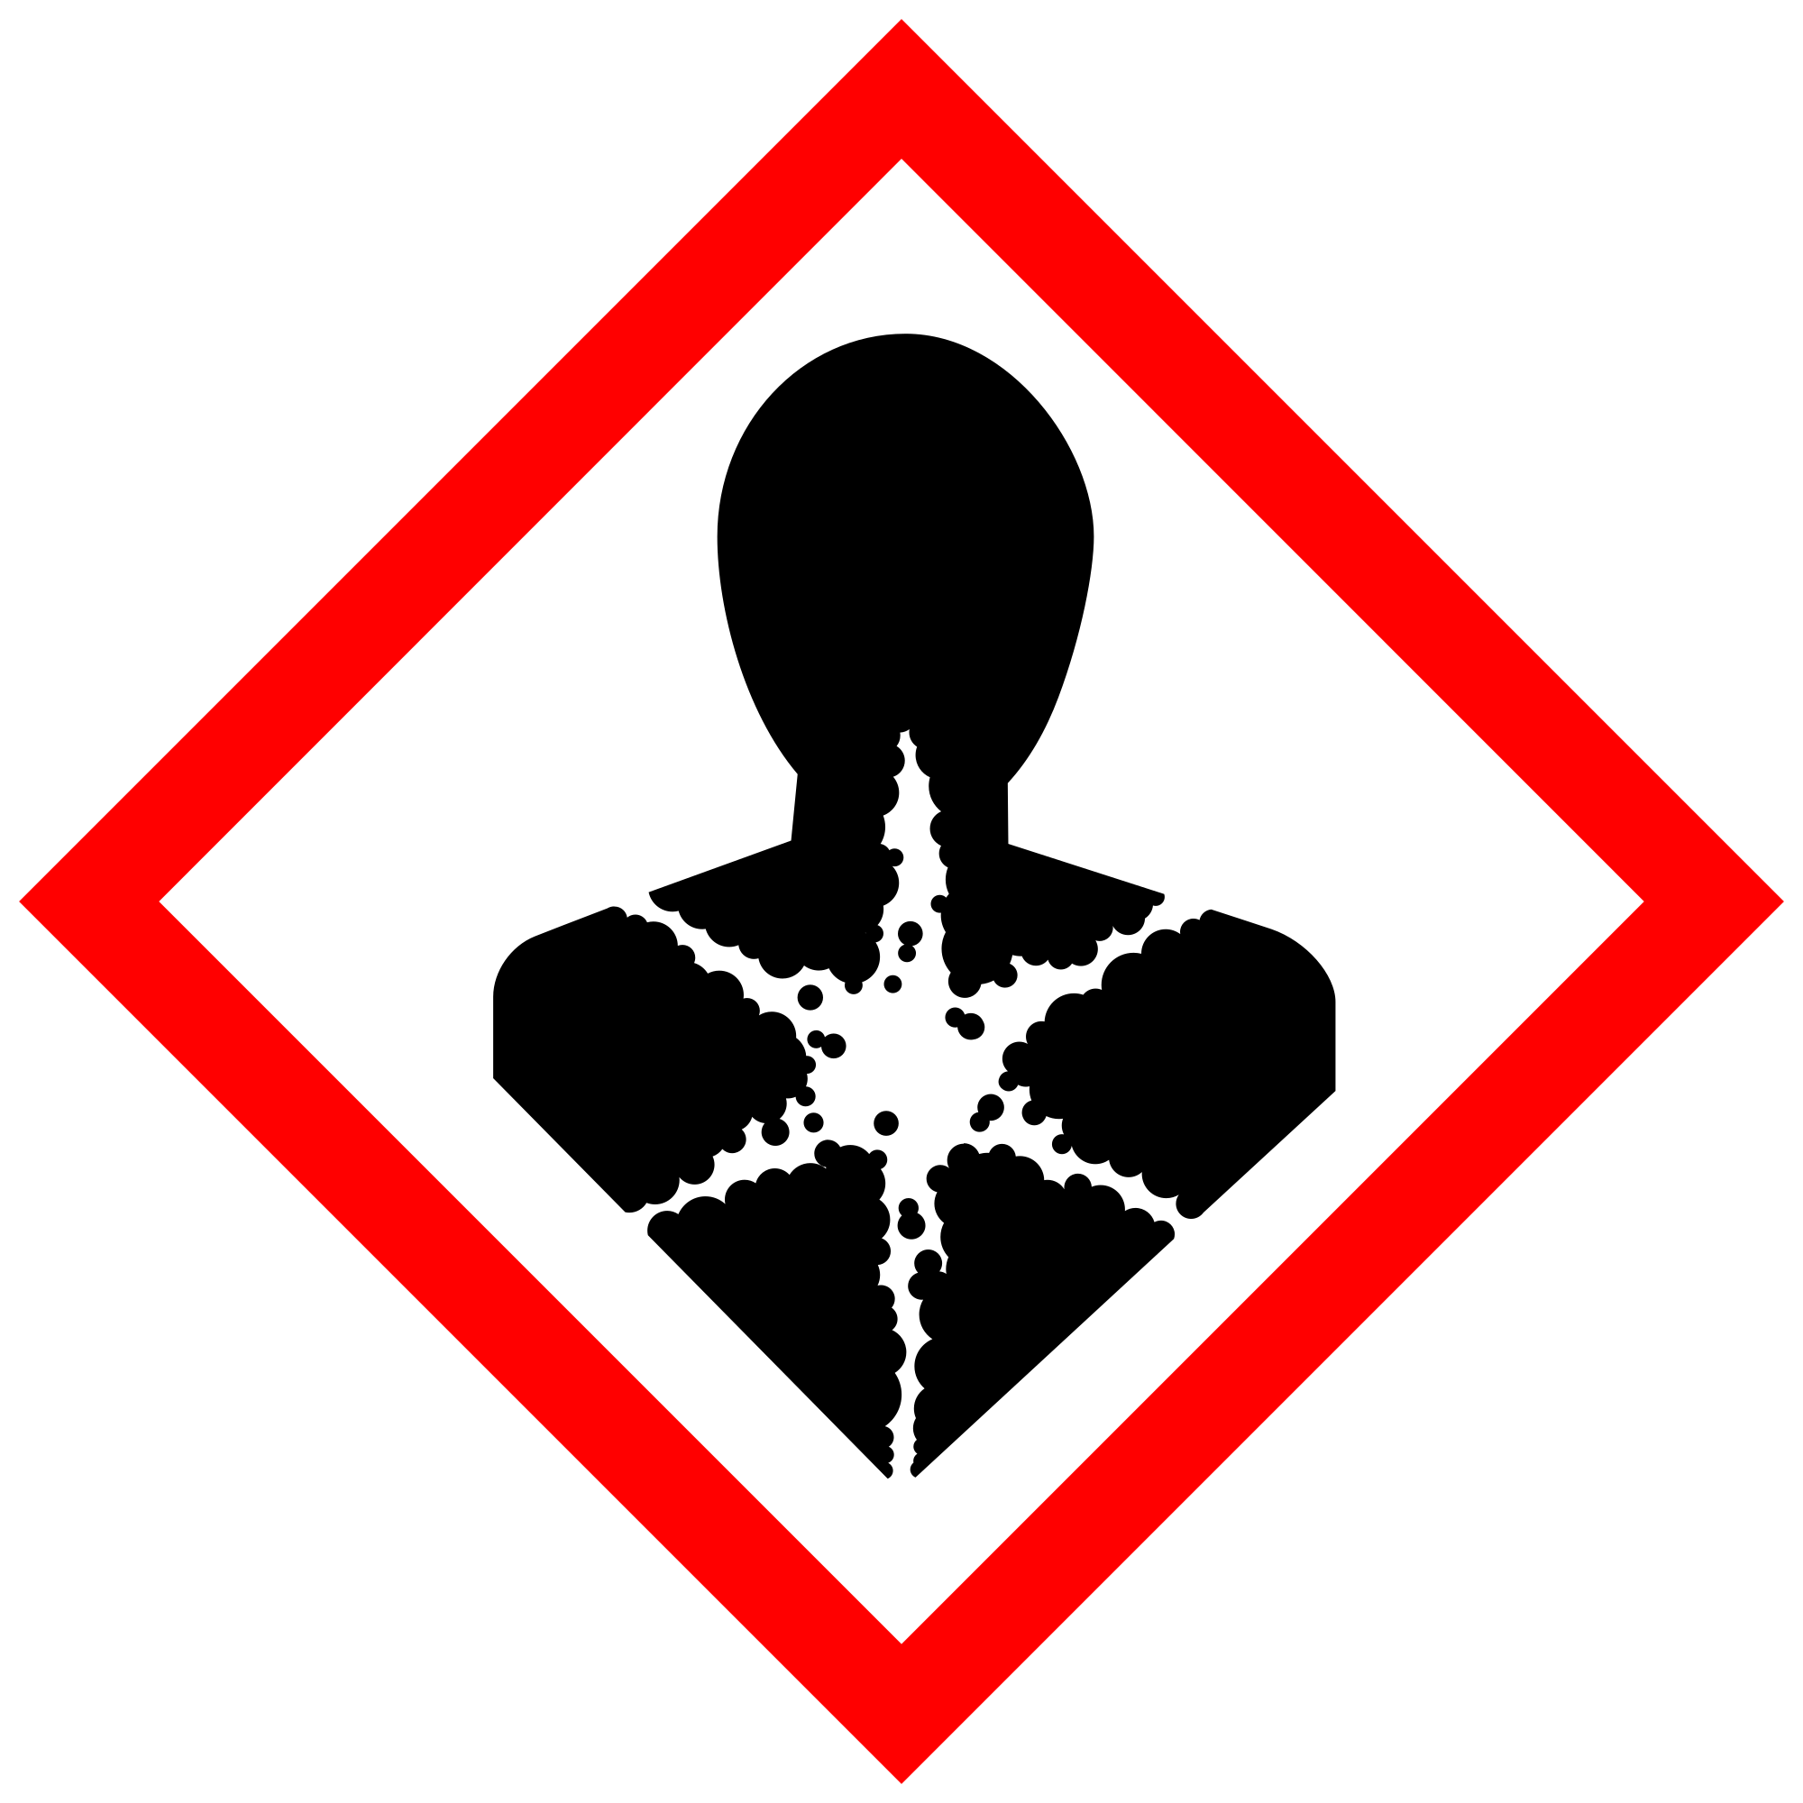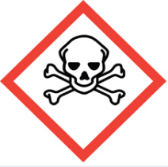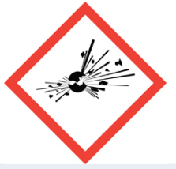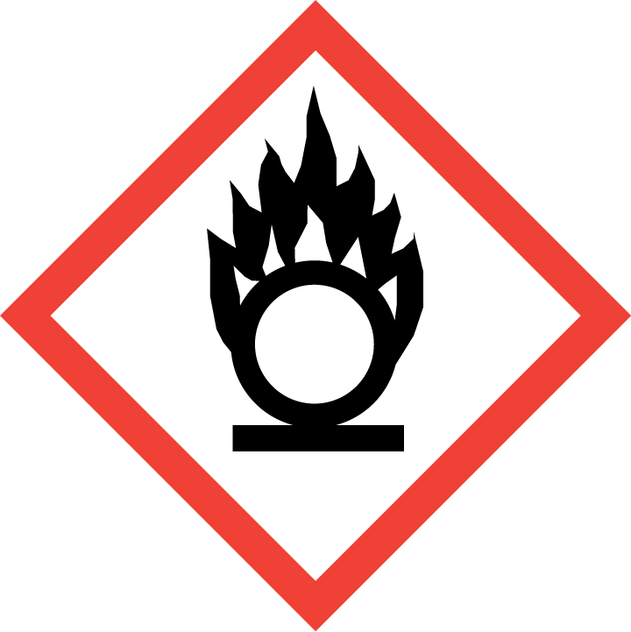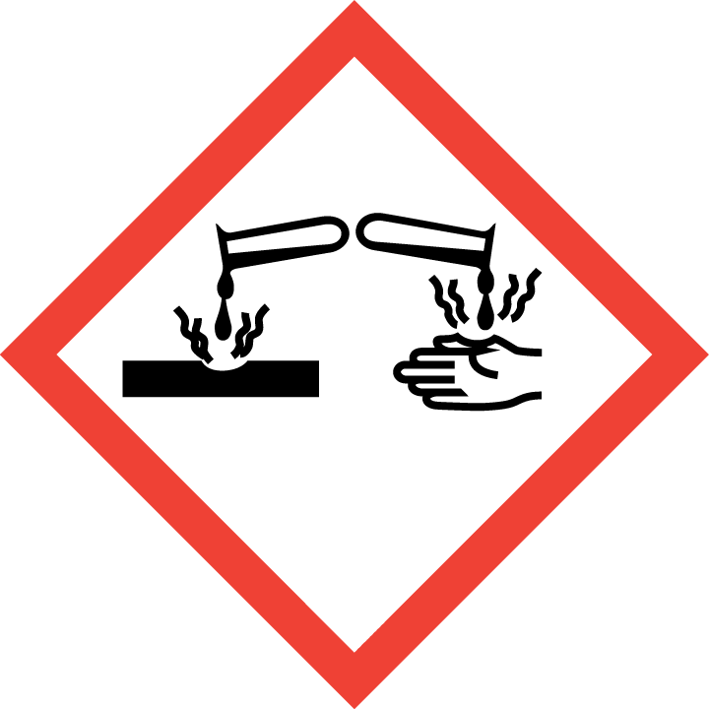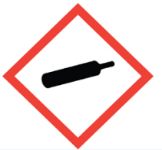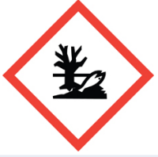

Section 3 – Environmental/Ventilation Controls
Using certain classes of chemicals, including particularly hazardous chemicals (i.e., highly toxic, reproductive toxicity, select toxins, carcinogens, corrosives, strong oxidizers, otherwise dangerous) under certain conditions (i.e., at elevated temperatures) may require facility-specific engineering/ventilation controls. Refer to the chemical SDS and WWU Chemical Hygiene Plan Appendix 7B for definitions and partial lists of some particularly hazardous substances. Contact WWU EHS for engineering control details.
REQUIRED - Insert descriptions of lab-specific engineering or ventilation controls used to reduce chemical exposures (e.g.,fume hoods, snorkels, glove boxes, reverse flow laminar benches, biosafety cabinets, etc.) or specific equipment safety features.
Section 4 –Personal Protective Equipment (PPE)
General Hygiene Measures:
Avoid contact with skin, eyes, and clothing. Wash hands after removing PPE before breaks and immediately after handling the chemical. If chemical(s) come(s) into contact with any PPE, the PPE shall be immediately removed and discarded properly. Any potentially exposed body parts should be washed immediately.
PPE: Includes gloves, lab coats, etc. and is the minimal method of protection if alternatives are available. PPE must be specified completely, such as type, and whether necessary for the entire process or at certain steps.
Skin and Body Protection. Personnel must wear full-length pants, or equivalent, and close-toed shoes. The area of skin between the shoe and ankle must not be exposed.
If lab coats are required, they must be chemically compatible and be appropriately sized for the individual and buttoned to their full length. If a risk of fire exists, a flame-resistant laboratory coat that is NFPA 2112-compliant should be worn. Some FR fabrics (e.g., Nomex®, Rhovyl®, Kevlar®, etc.) are highly permeable and do not provide good chemical/acid resistance.
For chemicals that are corrosive and/or toxic by skin contact/absorption additional protective clothing (e.g.,face shield, chemically-resistant apron, disposable sleeves, etc.) are required where splashes or skin contact is foreseeable.
Hand Protection. Hand protection [IS/IS NOT] required for the activities described in this SOP.
Specify glove type required [manufacturer and item #] NOTE: Consult with your preferred glove manufacturer to ensure that the gloves you plan to use are compatible with the specific chemical being used.
REQUIRED - Insert the lab-specific gloves or glove combination that are required. When possible, include the exact manufacturer and model information.
Gloves must be inspected prior to use, including a check for pinholes.
Use proper glove removal technique (without touching glove's outer surface) to avoid skin contact with this product. Dispose of contaminated gloves after use in accordance with applicable laws and good laboratory practices. Wash and dry hands immediately after glove removal.
Eye Protection. ANSI Z87.1-compliant eye protection [IS/IS NOT] required for all work with substance(s). Ordinary prescription glasses will NOT provide adequate protection unless they also meet the Z87.1 standard and have compliant side shields. Specify minimum eye protection required (splash goggles, safety glasses, safety goggles, face shields).
Respiratory Protection. Respiratory protection [IS/IS NOT] required for the activities described in this SOP.
Respirators should be used as a last line of defense (i.e., after engineering and administrative controls have been exhausted), and when any Action Limit (AL) or Occupational Exposure Limit (OEL) has been exceeded or when there is a possibility that an AL/OEL will be exceeded. Respiratory protection may be needed if dust, aerosol or vapor hazard is present and work is conducted outside of the fume hood. If any procedure may pose an external hazard it should be eliminated or strictly isolated. If a potential exposure hazard cannot be eliminated, contact EHS to discuss respiratory protection or to enroll in the program so a respiratory protection analysis can be performed. Program enrollment includes medical evaluation, training, and fit testing for an appropriate respirator. For information, see the Respiratory Protection Program document or contact EHS. Where air-purifying respirators are appropriate, use a full-face respirator with appropriate respirator cartridges as a backup to engineering controls. Use a full-face supplied air respirator if it is the sole means of protection.
Section 5 – Special Handling and Storage Requirements
- Describe administrative controls, such as transportation in secondary containment, purchase of pre-formulated liquids instead of powders.
- Identify procedures beyond general laboratory rules that are required for the chemical(s).
- Identify best practices used to minimize accidents (temporary hazard signs when personnel are absent, etc.)
- Specify limits, if any, to the amount of chemicals/reactants during process.
- Describe special storage requirements:
  - secondary containment?
  - locked cabinet?
  - incompatible chemical groups (check the SDS)
  - Container type(s)
  - Special precautions, e.g., keep away from heat, light, air, flames, sources of ignition.
- Transport requirements.

- Clean the [Specify Ventilation Control] upon completion of tasks with [specify cleaning solution].
- Clean all contaminated surfaces with [specify cleaning solution] and dry.
- Place all contaminated disposable items in appropriate laboratory waste for disposal.
- Non‐disposable/re‐usable utensils, glassware, and other surfaces contaminated with [chemical(s)] must be decontaminated at the end of the laboratory work session. Complete this inside [Specify Ventilation Control] before removing any of the items.
- When work is completed, remove gloves and wash hands with soap and water.
REQUIRED - Insert descriptions of any additional administrative controls (e.g., restrictions on procedure/quantity/work equipment/work locations/unattended operations/etc.), including controls that may be chemical-specific (e.g., peroxide formers).

Section 6 – Spill and Accident Procedures
Chemical spills must be cleaned up as soon as possible by properly protected and trained personnel. All other persons should leave the area. Spill response procedures must be developed based on the chemical and potential spill or release conditions. Clean up spills using contents of the laboratory spill kit: [describe types of spill clean-up materials required]. Do not attempt to clean up any spill if not trained or comfortable. Evacuate the area and call EHS at 360.650.3064 during business hours (8am-5pm) or emergency services at 360.650.3911 or 911 outside of business hours. If the spill is out of control, call 360.650.3911 or 911. If a person is injured, exposed or suspected of being exposed, call 360.650.3911 or 911. *Follow EXPOSURE PROCEDURES (below).
- Spill response procedures must be developed based on the chemical (refer to SDS) and potential spill or release conditions and using the appropriate spill kit. Describe how spills or accidental releases should be handled and by whom.
- Differentiate small vs. large spills, spills in hood vs. outside of hood. For example, spills less than 100mL within fume hood may be easily handled by staff, spills greater than 10mL outside of fume hood may not be safely handled.
- Differentiate liquid vs. powder spills: materials and procedures.
- Specify any signage, entry restrictions that are required.
- Include appropriate/additional PPE required for spill cleanup. For chemicals that are corrosive and/or toxic by skin contact/absorption, additional protective clothing (e.g.,face shield, chemically-resistant apron, disposable sleeves, etc.) are required where splashes or skin contact is foreseeable.
Spill area must be cleaned up in the following manner: [describe cleaning materials and methods, for example: clean spill area thoroughly with detergent solution followed by clean water].
Spill cleanup materials must be disposed of in the following manner: [describe packaging and disposal of waste materials, for example: double bag all waste in plastic bags labeled with the contents. Submit request to EHS for pickup].
Any spill incident requires the involved person or supervisor to complete and submit an Incident Report within 24 hours of the incident to EHS. For any incidents that resulted in hospitalization or death, EHS must be contacted as soon as possible at 360.650.3064 (8am-5pm) or 360.650.3555 outside of business hours. REQUIRED - Insert descriptions of any specialized spill clean up procedures for materials used in this SOP, including the procedures for corrosive spill cleanup. Additional details of lab-specific spill cleanup should be provided if applicable.
Exposures: If a person is injured, exposed, or suspected of being exposed to [chemical], follow procedures listed here:
Perform First Aid Immediately Refer to SDS for additional chemical-specific guidance, include pertinent information here.
- For inhalation exposure: move out of contaminated area; get medical help
- For sharps injury (needle stick or subcutaneous exposure): scrub exposed area thoroughly for 15 minutes using warm water and sudsing soap.
- For skin exposure: use the nearest safety shower for 15 minutes; stay under the shower and remove clothing; use a clean lab coat or spare clothing for cover‐up.
- For eye exposure: use the eye wash for 15 minutes while holding eyelids open.
Get Help
- Call 360.650.3911 or 911 or go to nearest Emergency Department (ED); provide details of exposure:
o Agent
o Dose
o Route of exposure
o Time since exposure
- Bring to the ED the SDS and this SOP
- Notify your supervisor as soon as possible for assistance
- Secure area before leaving; lock doors and indicate spill if needed
Report Incident to Environmental Health and Safety
Any exposure incident requires the involved person or supervisor to complete and submit an Incident Report within 24 hours of the incident to EHS. For any incidents that resulted in hospitalization or death, EHS must be contacted as soon as possible at 360.650.3064 (8am-5pm) or 360.650.3555 outside of business hours.
INSERT IF APPLICABLE - Descriptions of any specialized emergency procedures for locations outside of a UW campus or facility.
Section 7 – Waste Disposal Procedures
Describe waste disposal procedures for all related wastes.
Be aware that many laboratory accidents happen from inadvertent disposal of incompatible wastes into the same waste container. Therefore, identify different waste streams as appropriate.
Manage chemical and hazardous chemical waste separately from other waste streams such as biohazardous waste. Never autoclave chemical waste since it can produce hazardous chemical vapors, aerosols, and explosive reactions. Western Washington University Environmental Health and Safety Department has all responsibility for collection of hazardous waste for the University, including its offsite locations. This means that you cannot contract with an outside vendor to collect your waste unless you have received written approval from EHS.
In certain cases, chemical waste can be treated and disposed of into the sanitary sewer. You must receive written approval from EHS before treating any hazardous waste. Describe any applicable neutralization or treatment of wastes to ensure safe handling and minimize the amount of hazardous waste. All treated waste disposed into the sewer must be recorded.
Accumulate waste in a sturdy, [compatible container] with a securely-closable/screw‐ top lid. *Vented lids may be appropriate for certain chemicals.
REQUIRED - Insert descriptions of laboratory-specific information on the waste streams generated, storage location, and any special handling/storage requirements.
Include work area decontamination procedures as appropriate for the chemical in use:
REQUIRED - Insert descriptions of decontamination procedures for equipment, glassware, and controlled areas (e.g., glove boxes, restricted access hoods, perchloric/hot acid fume hoods, or designated portions of the laboratory).

Section 8 – Special Precautions for Animal Use (___Yes ___No)
Use of [chemical] in animals will be documented and approved by IACUC.
Annotate “N/A” if no animal exposure is involved. If chemicals are being administered to animals, describe how employees should protect themselves from contaminated animals and animal waste. Include all restricted access, chemical administration, aerosol suppression, PPE, and waste disposal procedures required.

PARTICULARLY HAZARDOUS SUBSTANCE INVOLVED? | YES: | Sections #9 to #11 are Mandatory
 | NO: | Sections #9 to #11 are Optional.

Section 9 – Approvals required
All staff working with [chemical] must be trained on this SOP prior to starting work. They must also review the [chemical] SDS, and it must be readily available in the laboratory. All training must be documented and maintained by the PI or their designee.
Describe any requirements for obtaining authorization before use of the chemical for the procedure, operation, or activity can be performed, for example:
- A worker must have [specific training] documented before performing described procedure for the first time.
- A medical examination must be completed prior to respirator use (for lead, dust, pathological organisms).
- -Other authorizations required before a person can independently perform a process using a particularly hazardous substance.

Section 10 – Decontamination
Include work area decontamination procedures as appropriate for the chemical in use:
REQUIRED - Insert descriptions of decontamination procedures for equipment, glassware, controlled areas (e.g., glove boxes, restricted access hoods, perchloric/hot acid fume hoods, designated laboratory areas), include cleaning solutions and materials.

Section 11 – Designated Area

REQUIRED - Identify specific areas where the particularly hazardous chemicals may be used (e.g., glove boxes, restricted access hoods, perchloric/hot acid fume hoods, or designated portions of the laboratory).

Section 12 – Documentation of Training (signature of all users is required)
- Prior to using substances included in this SOP, laboratory personnel must be trained on the hazards described in this SOP, how to protect themselves from the hazards, and emergency procedures.
- Ready access to this SOP and to a Safety Data Sheet for each hazardous material described in the SOP must be made available in the lab space(s) where these substances are used.
- The Principal Investigator (PI), or Responsible Party, if the activity does not involve a PI, must ensure that their laboratory personnel have attended appropriate laboratory safety training (and refresher training where applicable).
- Training must be repeated following any revision to the content of this SOP. Training must be documented. This training sheet is provided as one option; other forms of training documentation (including electronic) are acceptable but records must be accessible and immediately available upon request.
I have read and understand the content of this SOP:
Name | Signature | Date
Click here to enter text. |  | Click here to enter a date.
Click here to enter text. |  | Click here to enter a date.
Click here to enter text. |  | Click here to enter a date.
Click here to enter text. |  | Click here to enter a date.
Click here to enter text. |  | Click here to enter a date.
Click here to enter text. |  | Click here to enter a date.
Click here to enter text. |  | Click here to enter a date.
Click here to enter text. |  | Click here to enter a date.
Click here to enter text. |  | Click here to enter a date.
Click here to enter text. |  | Click here to enter a date.
Click here to enter text. |  | Click here to enter a date.
Click here to enter text. |  | Click here to enter a date.
Click here to enter text. |  | Click here to enter a date.
Click here to enter text. |  | Click here to enter a date.
Click here to enter text. |  | Click here to enter a date.
Click here to enter text. |  | Click here to enter a date.
Click here to enter text. |  | Click here to enter a date.
Click here to enter text. |  | Click here to enter a date.

